# Abstract

**Background:** Health related quality of life following a stroke can vary greatly, and depends on how disabling the stroke is. The modified Rankin Scale (mRS) categorises disablement in seven discrete categories. By convention, the state following stroke is commonly categorised into three categories with cost-effectiveness models: death, dependent state, and independent state. A recent Medical Decision Making paper maps between EQ-5D utility and mRS score.

Objective: To explore a simulation approach for mapping utilities onto dependent and independent states using results presented in the MDM paper, and compare these estimate with existing utility estimates for dependent and independent states.

**Methods:** A statistical simulation based algorithm is developed and applied to map between mRS states onto dependent and independent states, using

Setting,

Patients,

Intervention (if any),

Measurements,

**Results,**

**Limitations,**

**Conclusions.**

# Structure

## Introduction

The outcomes following a stroke can vary markedly in terms of their severity, affecting both the quality of life of patients with strokes, and the costs of treating them. A recent paper published in Medical Decision Making reported utility estimates associated with different modified Rankin Scale (mRS) scores, based on a large scale and recent UK-based population cohort study. (1) However, estimates of costs and utilities associated with stroke used within recent mathematic models have often divided patient outcomes into the three ordinal states of dead, dependent state, and independent state, rather than the seven ordinal states of the mRS. In order to allow comparability between results from the mRS-to-EQ-5D paper and previous economic evaluations that have used the three-state division of stroke outcomes, and in order to make use of cost estimates associated with dependent and independent states following strokes, it is necessary to map the seven mRS states onto the three states of dead, dependent, and independent.

This paper describes and presents the results of a simulation-based approach to estimating both the proportions dead, and in dependent and independent states following a stroke, and the mean utilities associated with dead and independent states. This simulation-based approach involves making fewer assumptions in mapping from seven to three states than many analytic approaches would require, and can be readily applied to similar mapping approaches. As an illustration of this latter point, and as the categories of the mRS differ according to degree of disability rather than type of stroke, the paper briefly describes how the approach could be used to map from the seven states of the mRS to the five states of the Glasgow Outcome Score(2).

## Method: What did we do?

### Introduce source paper

The mRS to EQ-5D mapping used data from the Oxford Vascular Study (OXVASC), which is a large scale population-based cohort, initiated in 2002, involving almost 100,000 individuals registered in Oxfordshire. The mRS to EQ-5D paper used 1283 patients from this study, recruited between April 2002 and March 2007, who had suffered either stroke or transient ischemic attack (TIA). These patients were followed-up for up to 24 months following the stroke. The patients’ condition was assessed using the disease specific measure of the mRS, as well as the generic utility instrument EQ-5D. Based on this, the EQ-5D utilities associated with each state were estimated and reported.

### The Modified Rankin Scale

The mRS is a commonly used measure of disability or dependence in daily activities following a stroke. It was introduced in its current form by van Swieten et al in 1988(3), and originally based on a 1957 paper by J Rankin.(4) The mRS is a seven level ordinal scale, with scores ranging from 0-6 inclusive, and has good inter-rater reliability.(5) mRS category six is dead; the other six categories are shown in Table 1 below:

|  |  |  |
| --- | --- | --- |
| **mRS Score** | **Category** | **Description** |
| 0 | No Symptoms | No symptoms at all. |
| 1 | No Significant Disability | No significant disability despite symptoms; able to perform all usual duties and activities. |
| 2 | Slight Disability | Slight disability; unable to perform all normal activities but able to look after own affairs without assistance |
| 3 | Moderate Disability | Moderate disability requiring some help but able to walk without assistance. |
| 4 | Moderately Severe Disability | Moderately severe disability; unable to walk without assistance and unable to attend to own bodily needs without assistance. |
| 5 | Severe Disability | Severe disability; bedridden, incontinent, and requiring constant nursing care and attention. |

Table The modified Rankin Score (mRS) categories

### Describe reduced categories

The aim of the algorithm is to map the seven mRS categories onto the three mutually exclusive states of ‘dead,’ ‘dependent’ and ‘independent’. By convention mRS states 0-2 are categorised as ‘independent’ states, and states 3-5 as ‘dependent’ states.

In performing the mapping from the seven states of the mRS to the three states defined above, a range of sources of uncertainty exist. Firstly, there is uncertainty about how each mRS state maps onto an EQ-5D-based utility score. Secondly, there is uncertainty about the relative proportions of patients in each of the constituent mRS states in each of the reduced states: i.e. the relative proportions of patients in mRS states 0-2 for independent strokes, and the relative proportion of patients in mRS states 3-5 for dependent strokes. The simulation approach described below incorporates both of these levels of uncertainty.

### Graphical Representation of Algorithm

The simulation approach used to map between the mRS states reported in Rivero-Arias et al 2010 to the three state categories is shown graphically in Figure 1 below. This describes both the statistical distributions used at each stage in the derivation, and the original data sources used within the Rivero-Arias et al paper.

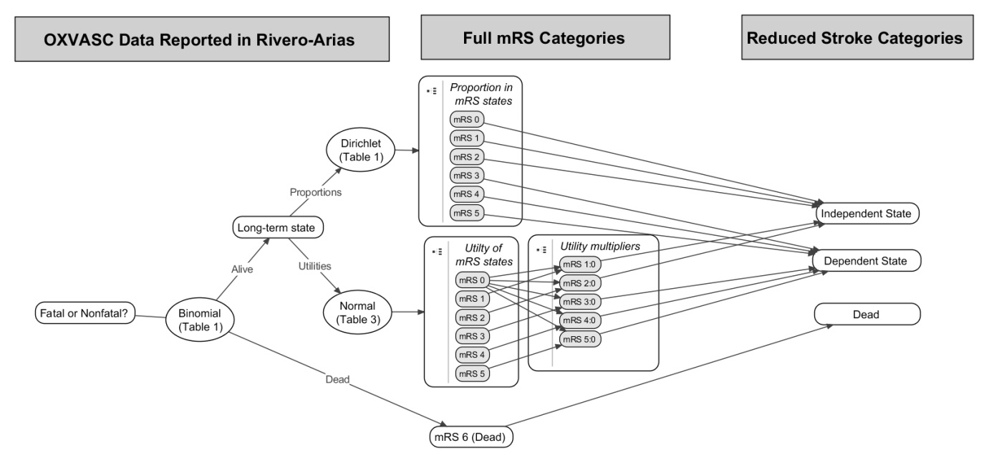

Uncertainty in the proportion of patients who survive a stroke was represented using a Binomial distribution. A Dirichlet distribution was used to represent uncertainty in the proportion of patients in each of the six mRS outcome states. These values were then converted back into estimated proportions of those alive in dependent and independent states following stroke.

### Description of Data

Rivero-Arias et al reported that, of the 1,283 patients who had a stroke within the Oxford vascular study (OXVASc) cohort, 24.8% (319 / 1,283) were dead within 24 months. Of those who survived, mRS scores following the stroke was graded according to the modified Rankin Scale (mRS) 24 months after the event in 425 patients. For simplicity this 24 month state is assumed to be the patient’s long-term condition, and the patients for whom mRS outcomes were reported were assumed to be representative of those for whom the data were not collected. The ordinary least squares (OLS) based mean estimates for the utility associated with each state, combined with the standard deviations around these mean estimates, were also reported. For convenience these values are reproduced in Table 2 below

|  |  |  |  |  |
| --- | --- | --- | --- | --- |
| **mRS State**  (Of those responding at 24 months following stroke) | **Equivalent Reduced Category** | **Frequency** | **Utility Estimate** | |
| **Mean** | **SE** |
| 0: No Symptoms | Independent | 61 | 0.959 | 0.074 |
| 1: No Significant Disability | 143 | 0.812 | 0.181 |
| 2: Slight Disability | 111 | 0.656 | 0.218 |
| 3: Moderate Disability | Dependent | 82 | 0.545 | 0.277 |
| 4: Moderately Severe Disability | 24 | 0.248 | 0.281 |
| 5: Severe Disability | 4 | 0.020 | 0.046 |

Table the modified Rankin Score (mRS) categories, and previously reported utility estimates

### Estimating proportions and utilities

As average utility differs by age, gender, and other characteristics,(6) utility multipliers, rather than the utility values themselves, were estimated from the above data in order to make the utility estimates more generalizable to other populations. As the mildest of the categories, mRS 0, is a full recovery, this is assumed to represent baseline patient utility. Multipliers for mRS 1-5 were thus calculated by dividing utility estimates of these worse states by the utility estimates of mRS 0.

Uncertainty in both numerators and denominators were estimated using a simulation approach, with 10,000 random draws from EQ-5D estimates of each of the states mRS 1-5 divided by 10,000 random draws from the EQ-5D estimates for state mRS 0. Although increasing the number of random draws would, on average, lead to greater precision in terms of the simulation error associated with the estimation of any given quantile (such as the median score, the 2.5% centile and the 97.5% centile), the number of draws should not lead to biased estimates of these quantiles.

In order to derive estimates of the utility multiplier associated with both dependent and independent strokes, the proportion of each of the constituent mRS states within the dependent and independent stroke category needs to be estimated. Uncertainty in our knowledge of these proportions thus also needs to be represented. This is done as follows:

1. Sample from a Dirichlet distribution with all six mRS states;
2. Divide the six states into the independent stroke category (mRS 0-2) and dependent stroke category (mRS 3-5);
3. Calculate the relative proportion of mRS states 0-2 within the independent stroke category, and relative proportion of mRS states 3-5 within the dependent stroke category;
4. Weight utility multiplier estimates of mRS states 0, 1, and 2 in proportion to these states’ relative prevalence within the independent stroke category; and weight utility multiplier estimates of mRS states 3, 4, and 5 in proportion to these states’ relative prevalence within the dependent stroke category.

To estimate uncertainty around the mean utility multiplier for dependent and independent stroke multipliers, the mean values of 10,000 bootstraps of the distributions produced were then calculated in order to estimate both the means and uncertainty around the means. By using bootstrapping at this stage, we are able to avoid the large standard deviations associated with the small sample sizes of some of the outcome categories leading to over-inflated estimates of uncertainty, which suggest either that the plausible range of uncertainty in our mean utility estimates for dependent states exceeds that of independent states a significant proportion of the time, or predicts utility scores of above one.

### Mapping between mRS and GOS states

As a secondary objective of this research, the algorithm was modified to map from the seven mRS states to the five separate states of the Gloasgow Outcome Scale (GOS) , which describe degree of disability following a traumatic brain injury. Table 3 shows the assumptions made about how the mRS states compare with GOS states.

|  |  |
| --- | --- |
| **Glasgow Outcome Scale** | **Assumed equivalent to** |
| GOS 2: Vegetative State | mRS 6: dead |
| GOS 3: Severely disabled | mRS 4: moderately severely disabled; and mRS 5: severely disabled |
| GOS 4: Moderately disabled | mRS 2: slight disability; and  mRS 3: moderate disability |
| GOS 5: Good recovery | mRS 0: no symptoms; and  mRS 1: no significant disability |

Table Assumed relationship between GOS and mRS, and estimated utility multipliers for each GOS state

## Results: What did we find?

### Introduction

[Write something here]

### Proportions of live patients in dependent and independent states

Of those with mRS states recorded at 24 months, 74.1% of those living after a stroke were in an independent state, and 25.9% were in a dependent state. The distribution of mRS states within each of the higher level dependent and independent stroke categories is heavily skewed, as indicated in Figure 2. This provides evidence of the need to take into account the weighting of the various distribution of mRS states within both the dependent stroke and independent stroke categories.

**Figure 2: Distribution of stroke outcomes at 24 months (survivors at 24 months only)**

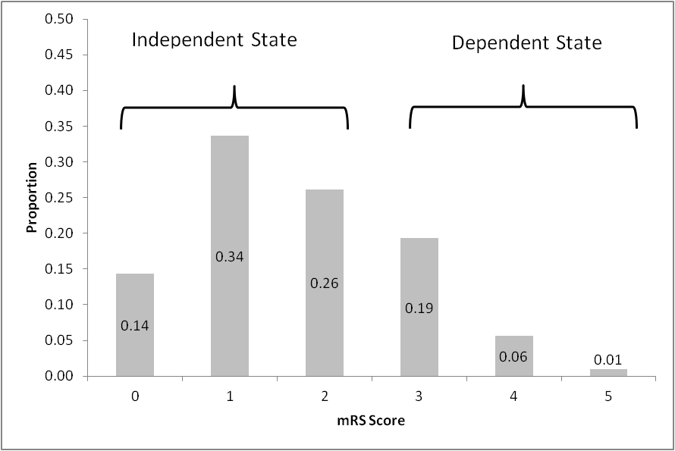

### Simulated proportions of patients in each of the three states

Using the simulation approach described above, the estimated proportion of long term outcomes following a stroke in each of the three states, together with 95% credible intervals, is presented in in table 4, and shown graphically in figure 3.

**Table 4: Estimated proportions of patient states following a stroke**

|  |  |  |
| --- | --- | --- |
| **State** | **Central Estimate** | **95% intervals** |
| Dead | 0.25 | 0.23 to 0.27 |
| Independent | 0.56 | 0.52 to 0.59 |
| Dependent | 0.19 | 0.16 to 0.23 |

**Figure 3: The estimated distribution of patients 24 months after a stroke.**

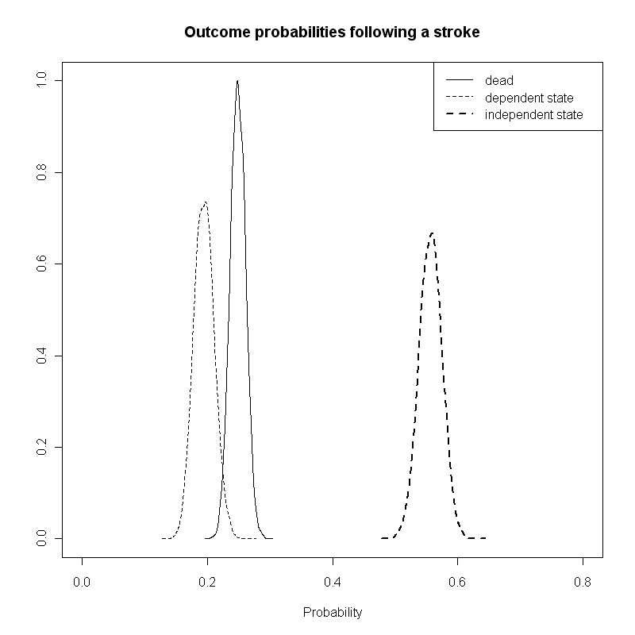

### Estimated utility associated with dependent and independent states

Using the approach described above, our central estimates for the utility associated with dependent and independent states, together with 95% credible intervals, is shown in table 5 below.

**Table 5: The estimated utility multipliers following a non-fatal stroke**

|  |  |
| --- | --- |
| **Category** | **Central utility estimate (95% CrIs)** |
| Independent State | 0.822 (0.819 to 0.824) |
| Dependent State | 0.482 (0.477 to 0.487) |

For simplicity, it was assumed that patients who sustained a stroke that caused mortality accrued no further QALYs. This is a limitation as not all patients would have died instantly. However, data were not identified that could be used to accurately populate this parameter.

### Secondary Objective: estimated utilities following an intracranial haemorrhage

Using the approach and assumptions described above, we derived the estimates (with 95% credible intervals) for the utilities associated with each GOS state shown in table 5 below:

TABLE 5: Utilities associated with each GOS state, based on mapping from EQ-5D to mRS to GOS

|  |  |
| --- | --- |
| **Glasgow Outcome Scale** | **Utility multiplier** |
| GOS 2: Vegetative State | 0 |
| GOS 3: Severely disabled | 0.226 (95% CI 0.221 to 0.231) |
| GOS 4: Moderately disabled | 0.642 (95% CI 0.638 to 0.645) |
| GOS 5: Good recovery | 0.895 (95% CI 0.892 to 0.898) |

[Write something more here]

### Summary

[Write something here]

## Discussion:

### Para 1: Summary of what found

[Write something here]

This study demonstrated that, using a fairly simple simulation-based approach, it is possible to map utility estimates for stroke in a way that incorporates all available information to calculate the proportion of patients

Approach developed when trying to determine downstream implications of prescribing an oral anticoagulant (OAC), which affects both risk of stroke and risk of bleeds. In case of major bleeds, the effects can be similar to those of strokes, so it is useful to estimate implications in terms of utility effects from the same patient dataset.

### Para 2: Shortcomings

Potential issue is that we assumed distribution of mRS states within GOS states is the same as within the OXVASC data. However, not a very strong assumption as …

For simplicity this 24 month state is assumed to be the patient’s permanent state until another event occurs, and the patients for whom mRS outcomes were reported were assumed to be representative of those for whom the data were not collected.

Assume patients die instantly.

Not sure how representative Oxfordshire is of the rest of the country. Not sure how relevant these findings are to international evaluations, due to differences in clinical practice.

Normal distributions assumed for utilities. Obviously wrong in the sense that the distribution ranges from negative to positive infinity, and so can include values greater than one. Also does not incorporate correlation between utility estimates for dependent and independent state. We should instinctively assume that a dependent state will have a lower utility than an independent state. However as values used to derive both states were drawn independently, it is possible that some estimates of the mean of dependent state may be higher than those of mean of independent state. In this case the utility estimates were different enough there was no violation of the assumption of monotonicity. This is an issue we are investigating elsewhere [ref].

### Para 3: How relates to other findings

Existing sources of utility estimates following stroke based on studies conducted some time ago [ref]. Outcomes following stroke may have changed since due to improvements in patient management.

Similar estimates for independent state despite very different methodology. Somewhat higher estimates for dependent states. Could this be due to improvements in clinical practice or choice of different thresholds?

Our estimated utility multipliers are very similar to those presented in Dorman et al.,149 for independent strokes but somewhat higher than those reported in that paper for dependent strokes. This is largely due to the distribution of mRS states within the Independent Stroke and Dependent Stroke categories, which for both categories of stroke are weighted towards less severe mRS states (as shown in Figure 9). In the case of dependent strokes (mRS 3-5), for example, only around 4% were the worst category mRS 5, which has an estimated EQ-5D score around zero, and around 75% were in the least worst category mRS 3, which has an estimated EQ-5D score over 0.5. The discrepancy may reflect improvements in the prognosis following strokes in the decade that separates the studies used.

### Para 4: Implications for Research

Further economic evaluations should use these estimates or derive new estimates in a similar way in order to ensure they reflect current rather than slightly outdated evidence on clinical practice.

Use of this data allows more variegated models to be used, with each mRS state represented within an economic model.

Relationship between mRS and Barthel Index.

### Para 5: Implications for clinical practice

The choice of estimates does not have a direct effect on clinical practice. Instead, it may have an indirect effect on clinical practice by affecting the results of cost-effectiveness models, which in turn may affect the decisions made by funding and commissioning bodies about which treatments are to be available on the NHS and similar healthcare bodies.

Potential implication is that, as a lot of variation of outcomes appears to exist within the ‘dependent state category’, it may be informative to subdivide this category.

### Para 6

[Write something here]

Relationship between disease specific and generic utility scales.

How disease specific is mRS? Is it generic in the sense of being a description of disabilities? Or disease specific in terms of being about strokes?

## Appendix

The R code used to produce the above simulations is reproduced below:

# This function produces bootstrapped CIs of means of a vector

Bootstrapper <- function(inputs, simulates = 10000){

X.mean <- vector("numeric", simulates)

N.inputs <- length(inputs)

for (i in 1:simulates) {X.mean[i] <- mean(inputs[sample(1:N.inputs, replace=T)])}

return(X.mean)

}

require(MCMCpack)

N.PSA <- 10000

# Dead/nondead following stroke:

# from Table 1: 319 dead out of 1283

Dead_nonDead <- rbinom(N.PSA, 1283, (319/1283)) / 1283

# mRS following stroke, if not dead

# from Table 1, 24 months

mRS_followingStroke <- rdirichlet(N.PSA, c(61, 143, 111, 82, 24, 4))

# three state reduction:

DepInd_followingStroke <- cbind(apply(mRS_followingStroke[,1:3], 1, sum), apply(mRS_followingStroke[,4:6], 1, sum))

DeadDepInd_followingStroke <- cbind(Dead_nonDead, (1 - Dead_nonDead) * DepInd_followingStroke[,1], (1-Dead_nonDead) * DepInd_followingStroke[,2])

apply(DeadDepInd_followingStroke,2, mean)

colnames(DeadDepInd_followingStroke) <- c("Dead", "Independent", "Dependent")

# Using table 3 (24 months column) from Rivero-Arias

s0 <- rnorm(N.PSA, .959, .074)

s1 <- rnorm(N.PSA, .812 , .181)

s2 <- rnorm(N.PSA, .656, .218)

s3 <- rnorm(N.PSA, .545, .277)

s4 <- rnorm(N.PSA, .248, .281)

s5 <- rnorm(N.PSA, .020, .046)

mult.s1 <- s1/s0

mult.s2 <- s2/s0

mult.s3 <- s3/s0

mult.s4 <- s4/s0

mult.s5 <- s5/s0

Stroke.Ind <- mRS_followingStroke[,1:3]

Stroke.Dep <- mRS_followingStroke[,4:6]

Stroke.Dep.sums <- apply(Stroke.Dep, 1, sum)

Stroke.Ind.sums <- apply(Stroke.Ind, 1, sum)

Stroke.Dep <- apply(Stroke.Dep, 2, function (x) x / Stroke.Dep.sums)

Stroke.Ind <- apply(Stroke.Ind, 2, function (x) x / Stroke.Ind.sums)

Stroke.Ind.utils <- Stroke.Ind[,1] * 1 + Stroke.Ind[,2] * mult.s1 + Stroke.Ind[,3] * mult.s2

Stroke.Dep.utils <- Stroke.Dep[,1] * mult.s3 + Stroke.Dep[,2] * mult.s4 + Stroke.Dep[,3] * mult.s5

n.bootstraps <- 10000

Stroke.Ind.utils.mean <- vector("numeric", n.bootstraps)

Stroke.Dep.utils.mean <- vector("numeric", n.bootstraps)

for (i in 1:n.bootstraps){Stroke.Ind.utils.mean[i] <- mean(Stroke.Ind.utils[sample(1:N.PSA, n.bootstraps, replace=T)])}

for (i in 1:n.bootstraps){Stroke.Dep.utils.mean[i] <- mean(Stroke.Dep.utils[sample(1:N.PSA, n.bootstraps, replace=T)])}

Stroke.Ind.utils.mean <- Bootstrapper(Stroke.Ind.utils)

Stroke.Dep.utils.mean <- Bootstrapper(Stroke.Dep.utils)

GOS_5 <- mRS_followingStroke[,1:2]

GOS_4 <- mRS_followingStroke[,3:4]

GOS_3 <- mRS_followingStroke[,5:6]

GOS_5.sums <- apply(GOS_5, 1, sum)

GOS_4.sums <- apply(GOS_4, 1, sum)

GOS_3.sums <- apply(GOS_3, 1, sum)

GOS_5 <- apply(GOS_5, 2, function (x) x / GOS_5.sums)

GOS_4 <- apply(GOS_4, 2, function (x) x / GOS_4.sums)

GOS_3 <- apply(GOS_3, 2, function (x) x / GOS_3.sums)

GOS_5.utils <- GOS_5[,1] * 1 + GOS_5[,2] * mult.s1

GOS_4.utils <- GOS_4[,1] * mult.s2 + GOS_4[,2] * mult.s3

GOS_3.utils <- GOS_3[,1] * mult.s4 + GOS_3[,2] * mult.s5

GOS_5.mean <- vector("numeric", n.bootstraps)

GOS_4.mean <- vector("numeric", n.bootstraps)

GOS_3.mean <- vector("numeric", n.bootstraps)

for (i in 1:n.bootstraps){

GOS_5.mean[i] <- mean(GOS_5.utils[sample(1:N.PSA, n.bootstraps, replace=T)])

GOS_4.mean[i] <- mean(GOS_4.utils[sample(1:N.PSA, n.bootstraps, replace=T)])

GOS_3.mean[i] <- mean(GOS_3.utils[sample(1:N.PSA, n.bootstraps, replace=T)])

}

# Notes

* Each paragraph should start with a clear message (a ‘topic sentence’)
* Try to do each sentence in one go (for consistency)

# Editing

## Micro-editing

### Is the information correct?

### Are requirements stated in ‘Instructions to authors’ met?

### Is the English clear and simple?

### Is the grammar and spelling correct?

## Macro-editing

### Is there a clear message?

#### Is there a clear message?

#### Is the message worth giving?

#### Is the message proven?

#### Where does the message appear

### Is the market appropriate?

### Is the structure appropriate?

#### Does it follow IMARD structure?

#### Are paragraphs clearly written?

### Is the tone appropriate?

## Yellow marker test

### Highlight most important sentences

#### Are the first sentences of paragraphs highlighted? (Otherwise meaning may be buried)

1. Rivero-Arias O, Ouellet M, Gray A, Wolstenholme J, Rothwell PM, Luengo-Fernandez R. Mapping the Modified Rankin Scale (mRS) Measurement into the Generic EuroQol (EQ-5D) Health Outcome. Medical Decision Making [Internet]. 2010;30(3):341–54. Available from: <Go to ISI>://000277892800009

2. Jennett B, Bond M. Assessment of outcome after severe brain damage. Lancet [Internet]. 1975 Mar 1 [cited 2012 Apr 4];1(7905):480–4. Available from: http://www.ncbi.nlm.nih.gov/pubmed/46957

3. van Swieten JC, Koudstaal PJ, Visser MC, Schouten HJ, van Gijn J. Interobserver agreement for the assessment of handicap in stroke patients. Stroke [Internet]. 1988 May 1 [cited 2012 Mar 18];19(5):604–7. Available from: http://stroke.ahajournals.org/cgi/doi/10.1161/01.STR.19.5.604

4. RANKIN J. Cerebral vascular accidents in patients over the age of 60. II. Prognosis. Scottish medical journal [Internet]. 1957 May [cited 2012 Apr 4];2(5):200–15. Available from: http://www.ncbi.nlm.nih.gov/pubmed/13432835

5. Wilson JTL, Hareendran A, Hendry A, Potter J, Bone I, Muir KW. Reliability of the modified Rankin Scale across multiple raters: benefits of a structured interview. Stroke; a journal of cerebral circulation [Internet]. 2005 Apr [cited 2012 Apr 4];36(4):777–81. Available from: http://www.ncbi.nlm.nih.gov/pubmed/15718510

6. Ara R, Brazier JE. Populating an economic model with health state utility values: moving toward better practice. Value in health : the journal of the International Society for Pharmacoeconomics and Outcomes Research [Internet]. 2010 Aug [cited 2012 Apr 4];13(5):509–18. Available from: http://www.ncbi.nlm.nih.gov/pubmed/20230546